Template for Departmental Activity Report

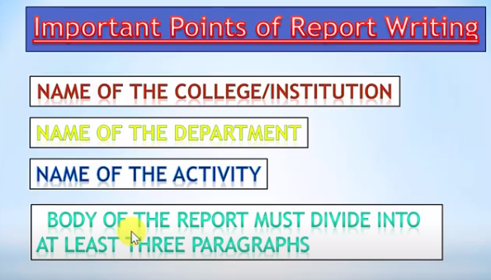
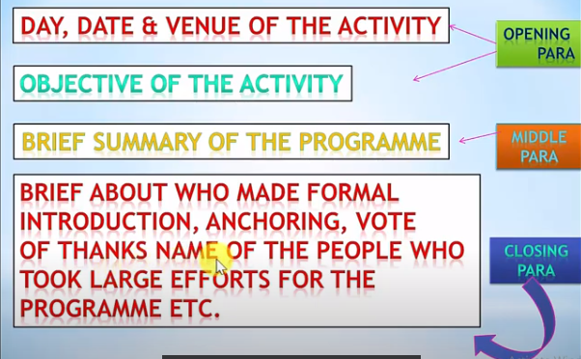
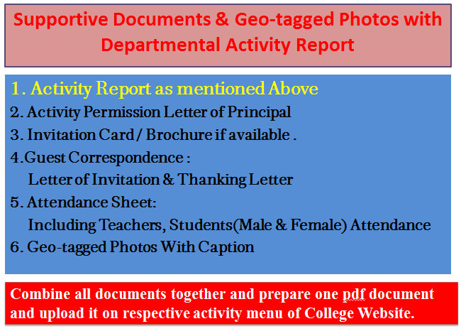
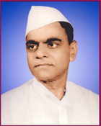
Janata Shikshan Sanstha’s
Kisan Veer Mahavidyalaya,Wai
Department of N.C.C.
A Guest Lecture on
Noise Pollution: Ways to Reduce
Report
A guest lecture on “Noise Pollution: Ways to Reduce” was organized by the department of NCC on 08-07- 2019. The Chief Speaker at this time was Dr. Vinod Veer, HOD, Department of Geography & E.V.S., Kisan Veer Mahaviodyalaya, Wai. Lieutenant Sameer Pawar welcomed Principal Dr. C. G. Yeole and Dr. Vinod Veer with a bouquet.

While addressing, Dr. Vinod Veer focused on the definition, types and consequences of noise pollutions. With the help of various suitable examples, he explained how pollution free atmosphere play an importanant role in the life of an individual. He also criticized human for not having sensible towards nature. He expressed fear that maximum people would suffer from deafness if we do not control noise pollution.

Mr Manoj Shinde, Assi. Director of Sports anchored the programme and Lieutenant Sameer Pawar gave an introductory speech. Mr. Gajanan Jadhav, Assi. Director of Sports offered the vote of thanks. 102 NCC cadets attended the program.

College Seal
Dr. C. G. Yeole Lieutenant Sameer Pawar
Principal NCC Officer
Kisan Veer Mahavidyalay, Wai NCC Unit
2. Activity Permission Letter of Principal

Paste the PDF

4. 4.Guest Correspondence:
Letter of Invitation & Thanking Letter

Paste the PDF
3. Invitation Card / Brochure if available

Paste the PDF

Combine all documents together and prepare one pdf document and upload it on respective activity menu of College Website.
Caption
Caption
Paste the PDF
Paste the PDF
Caption
Caption
Paste the PDF
Paste the PDF
5. Geo-tagged Photos With Caption

Paste the PDF
5. Attendance Sheet:
Including Teachers, Students
(Male & Female) Attendance

